ME 389   
Spring 2017  
  
AERO 01   
Vertical Take-off and Landing (VTOL)   
  
Block 3: 2/28 – 3/9  
  
Group 8  
Malcolm Erdongen, Brian Loughran  
  
ABSTRACT

In this report we attempt to control the vertical takeoff and landing in a simplified system. A fan and a counterweight are attached around a pivot, which allows only rotation in one direction. This is broken down into two subsystems. First, the response of the motor to an input current and second the VTOL pitch in response to motor current. A PID controller is applied to increase performance of the system.

|  |
| --- |
|  |
|  |

**Introduction:**

Vertical take-off and landing aircraft are that which can hover, take off, and land vertically. These include helicopters and some fixed wing aircraft. One successful example of this is the Harrier Jump Jet. These require sophisticated controllers as the user must have control over all 6 degrees of freedom of the vehicle (x, y, z position of the vehicle and xy, xz, yz moment). The system we use in this experiment is fixed in all buy one of the degrees of freedom, so all that is necessary to control is the pitch.

In this lab two controllers will be developed. First, we must modeled the motor current in response to input voltage. This was done using a PI controller. Next we modeled the system based on the equations of motion and the physical parameters of the system. A PID controller was applied to improve response and eliminate steady state error in the system. This PID controller was tested in simulation and with the experimental system.

**Apparatus and Procedure**

This experiment is a simplifies model of a vertical take-off and landing system. A figure is shown below to show our the apparatus (Figure 1)

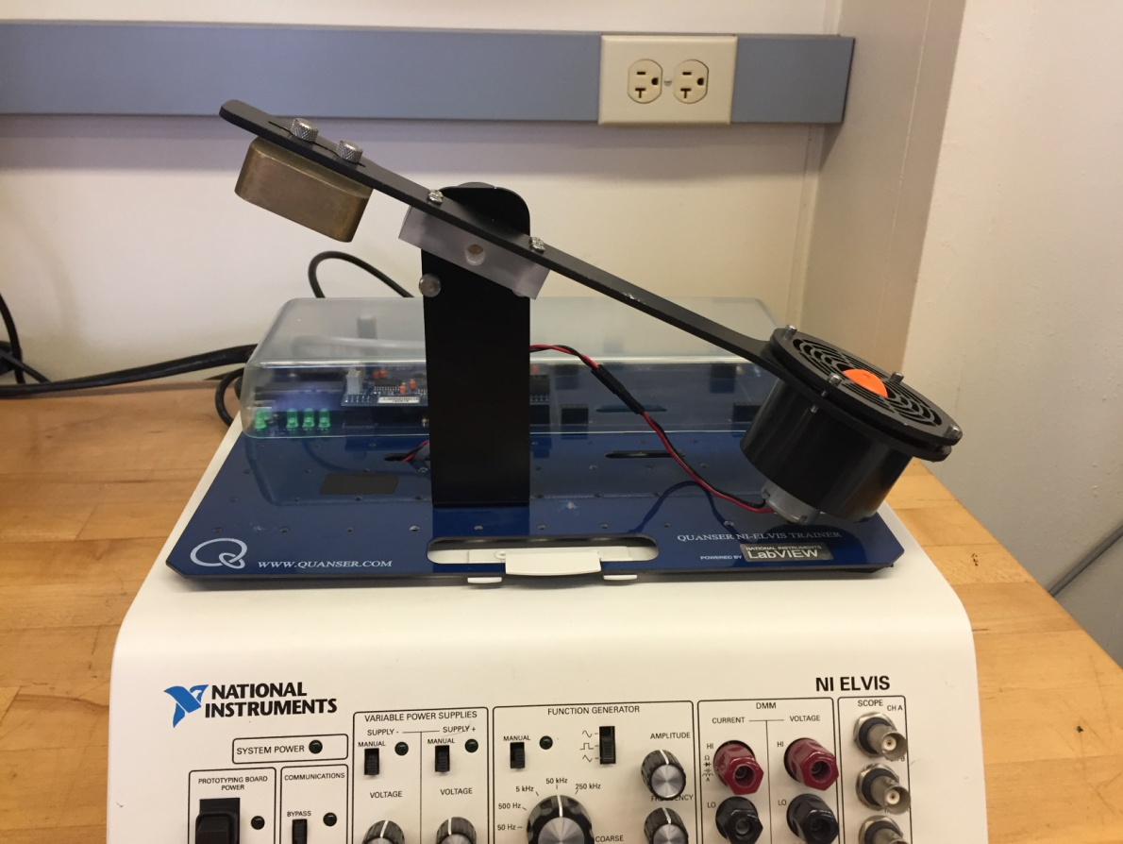

Figure 1 – Apparatus of lab equipment

In the figure above you can see that this experiment consists of a few key components. First there is a pivot point which limits the system to one degree of freedom (around the pivot point) which greatly simplifies our system. Next is the motor, which provides a lifting force to the right hand side of the pivot. There is a counter-weight on the attached to the left hand side of the pivot, which helps the motor to lift off. There is also a metal bar connecting the motor, counter weight, and pivot together. This is important to consider in the modeling component of the system.

Two controllers must be designed for this system. The first controls the input voltage, and gives the user control over the voltage going through the motor. The second controls the pitch of the system, improves performance of the system, and eliminates steady state error. To create this controller a sophisticated model of the system must be considered. Both controllers are tested in both simulation and experimentally.

**Control Design: Motor Resistance**

Using different values of voltage and current applied across the motor, we have come up with an average value for resistance of the motor (Rm) = 2.92. To match the input voltage to our input current to the motor, we must use a PI controller. To do this, it is important to consider the transfer function between motor voltage and motor current. This is given below in equation 1.

$$\frac{1}{L_{m}s+ R_{m}} (eq.1)$$

We were asked to design a PI controller to satisfy a natural frequency of 42.5 rad/s and a damping ration of 0.7. To do this we consider a PI controller of the following form.

$$PI= \frac{K_{P}s+ K_{i}}{s} (eq.2)$$

To do this, we must first close the loop of the controller (eq. 2) and system (eq. 1). When we do this, we get the following equation.

$$G_{CL}= \frac{K_{P}s+ K_{i}}{s^{2}L_{m}+ \left(K_{p}+ R_{m}\right)s+ K_{i}} (eq.3)$$

Comparing the denominator the closed loop system (eq. 3) with the following equation, and using given values for damping ratio and natural frequency, we can solve for values for Kp and Ki. The value for Lm is given as 53.8 mHz.

$$s^{2}+ 2 ζ ω_{n} s+ {ω_{n}}^{2} (eq.4)$$

Values for Kp and Ki were found to be 0.281 and 97.18, respectively. Our final PI current controller is given in the following equation.

$$PI= \frac{(0.281)s+ 97.18}{s} (eq.5)$$

**Error Modeling (Pitch Dynamics)**

We wish to determine the error dynamics of the pitch of the system based on a variety of controllers. Based on our findings, we will select a controller and implement it. First we are asked to find E(s) for the closed loop pitch system for a PID controller. The PID controller is of the form:

$$K_{P}+ K_{d}s+ \frac{K_{i}}{s} (eq.6)$$

The error function for a system is given by the following equation (where C(s) is the proposed controller, and P(s) is the plant transfer function)

$$E\left(s\right)= \frac{1}{1+C\left(s\right)P(s)} (eq.7)$$

After some algebra, we find that the error function is given by the following expression:

$$E\left(s\right)= \frac{J(s^{3}+ \frac{B}{J}s^{2}+ \frac{K}{J}s)}{J(s^{3}+ \left(K_{t}K_{d}+ B\right)s^{2}+ \left(K_{t}K_{p}+ K\right)s+ K_{t}K_{i}} (eq.8)$$

To determine steady state error inside of the frequency domain we must take the following limit:

$$SSError= \lim_{s→0}{s E(s)} (eq.9)$$

Evaluating this limit as s approaches 0 gives us an expected result, this is that the steady state error is zero. This bodes well for our PID controller.

We also consider a PD controller for this system. Using values of kp = 2 and kd = 1, we wish to find the steady state error of the system. Repeating the procedure laid out in (eq. 7 – 9) we find that the steady state error for a unit step for this controller is 0.632. Because of this, we determined that a PD controller would not be appropriate for our system.

We also considered a PI controller for the pitch dynamics. Upon trying this on the real system, however, we realized that the PI controller was unable to stabilize the system.

Because of these results, we decided to create a PID controller for the pitch dynamics.

**Control Design: PID Pitch Control**

We wish to control pitch with zero steady state error, a peak time of 1.0 s, and an overshoot of less than 20%. We can use these values to find values for damping ζ and natural frequency ωn using the following equations:

$$M_{P}= e^{\frac{-πζ}{\sqrt{1-ζ^{2}}}} \left(eq.10\right)$$

$$t_{r}= \frac{π}{ω_{n}\sqrt{1- ζ^{2}}} \left(eq.11\right)$$

Using these equations we find that desired values for the closed loop damping and natural frequency are 0.456 and 3.53 rad/s respectively.

Closing the loop of our PID controller (eq. 6) and our system we get the following transfer function:

$$G_{CL}\left(s\right)= \frac{K_{t}(K_{p}s+ K_{i})}{Js^{3}+ \left(K_{t}K_{d}+ B\right)s^{2}+ \left(K_{t}K_{p}+ K\right)s+ K_{t}K_{i}} (eq.12)$$

It is important to note that this closed loop transfer function is a third order system. So our traditional method of using (eq. 4) to find our damping and natural frequency will not work. But, we can approximate our transfer function as second order if we put a pole in the same location as the zero given by kps + ki. Consider the following transfer function:

$$\left(s^{2}+ 2 ζω_{n}s+ {ω_{n}}^{2}\right)\left(s+ p_{0}\right)= s^{3}+ \left(2 ζω_{n}+ p_{0}\right)s^{2}+ \left({ω_{n}}^{2} + 2 ζω_{n}p_{0}\right)s+ {ω_{n}}^{2}p_{0} (eq.13)$$

Matching the coefficients of the third order system and solving for the gains give the following series of equations:

$$K_{p}= \frac{-K+2p_{0}ω_{n}J+ {ω_{n}}^{2}J}{K_{t}} \left(eq.13\right)$$

$$K_{i}= \frac{p_{0}{ω_{n}}^{2}J}{K_{t}} \left(eq.14\right)$$

$$K_{d}= \frac{-B+ p_{0}J+ 2 ζω_{n}J}{K_{t}} (eq.15)$$

Solving (eq. 13 – 15) we find that our PID controller is of the following form:

$$4.963+ 2.22 s+ \frac{13.3}{s} (eq.16)$$

We can simulate the expected closed loop response of our plant and controller in MATLAB.

Doing this gives the following response to a unit step function.

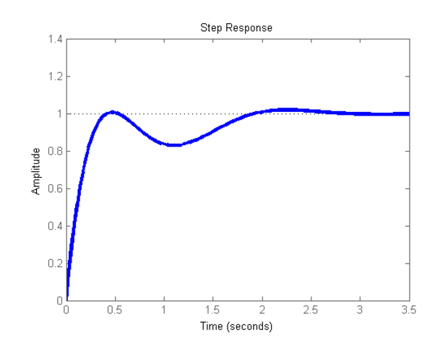

Figure 1: Pitch PID control response to a unit step

Visually we can see that this controller satisfies both design requirements. The rise time is less than 1.0 s and the overshoot is less than 20%, which is what we expect from this simulation.